September 06, 2020

Name: Iqbaluddin Mohammed

Problem Set 0

Harvard Extension School CSCI E-95:

Compiler Design and Implementation

Fall 2020

Due: September 6, 2020 at Midnight

Total of 20 Points

This problem set requires several different activities to be completed as detailed below:

1 o A GitHub account needs to be established.

ANS: Account has been established. Screen shot is pasted below:

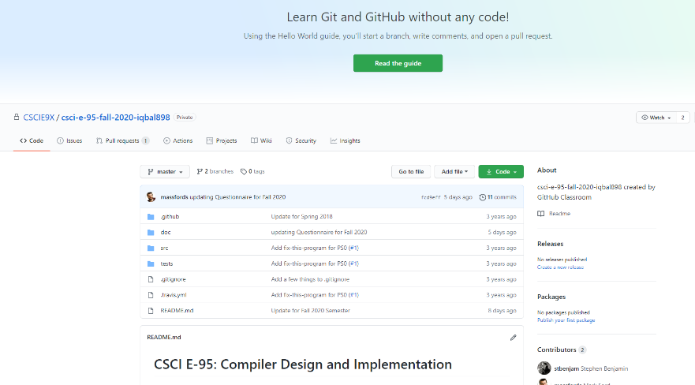

2 o A HarvardKey account needs to be established.

ANS: HarvardKey Account has been established.

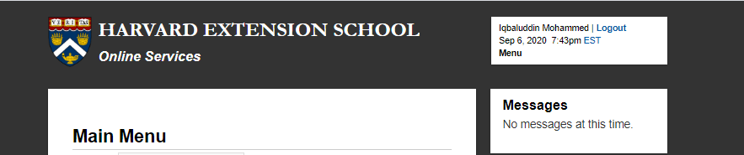

3 o A GitHub CSCI E-95 repository needs to be established.

ANS: GitHub CSCI E-95 repository has been established

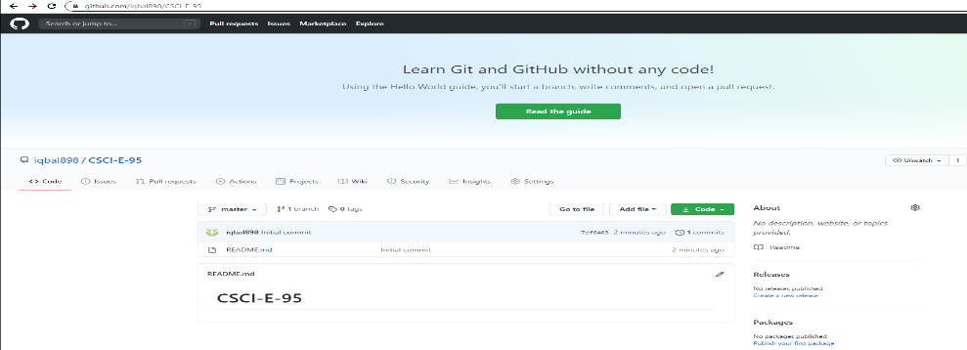

4 o Successful login to cscie95.dce.harvard.edu needs to be verified.

ANS: Successful login to cscie95.dce.harvard.edu has been established and verified

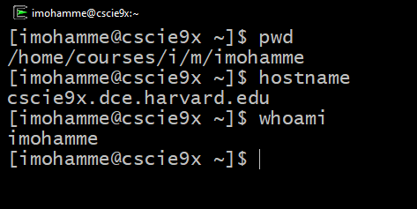

5 o git needs to be installed on computers on which you'll be developing code.

ANS: git has been installed on the computer.

6 o The course questionnaire needs to be completed.

ANS: Questionnaire has been completed

7 o The fix-this-program.c needs to be corrected so that it builds and runs correctly on cscie95.dce.harvard.edu.

ANS: fix-this-program.c has been corrected and it runs correctly on cscie95.dce.harvard.edu computer:

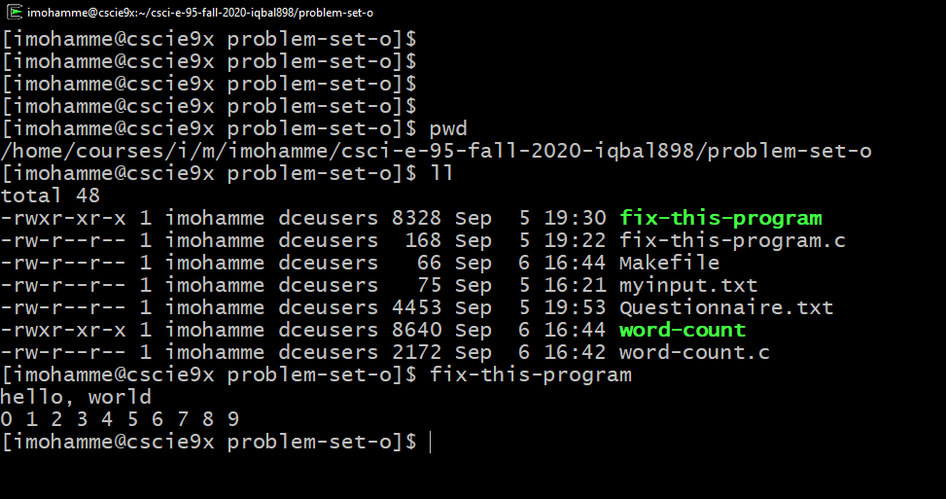

8 o word-count.c needs to be written and tested so that it builds and runs correctly on cscie95.dce.harvard.edu.

ANS: word-count.c has been written and tested and it runs correctly on cscie95.dce.harvard.edu computer:

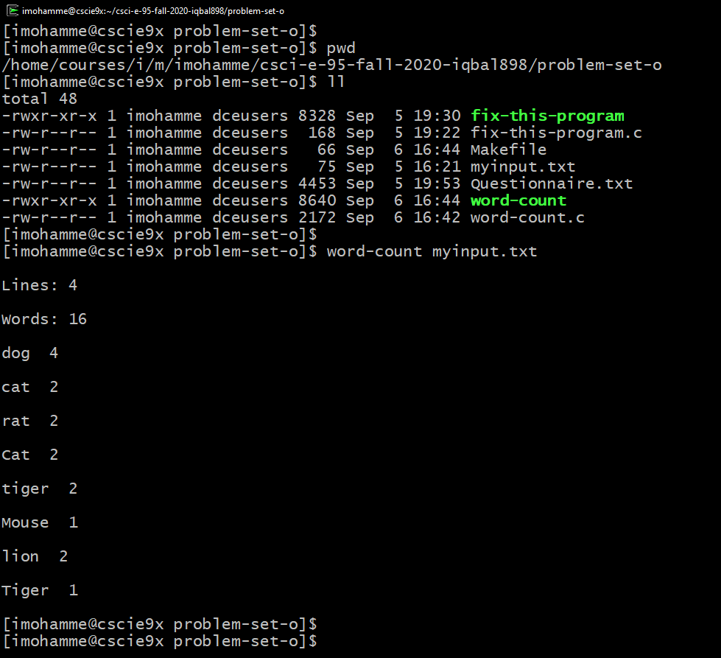

9 o The questionnaire, corrected fix-this-program.c, and word-count.c need to be submitted to your GitHub repository.

ANS: The questionnaire, corrected fix-this-program.c, and word-count.c have been submitted to the GitHub repository.